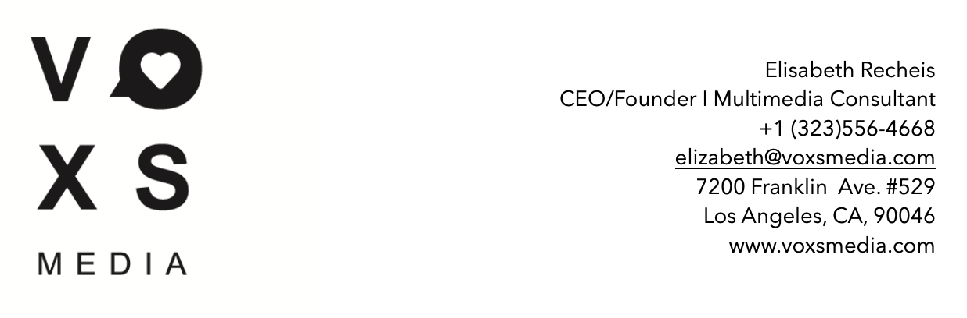

Questionnaire - Social Media Goal Setting:

Your Information:
Name:
Address:
Email:
Cell:
Company:

About - Tell us about your organization.

What category best describes your business?
1.Corporation - 2.Small Business - 3.Nonprofit - 4.Individual
&
Which ‘Multimedia Management Package’ would you be interested in most?

Links to Social Media Accounts we’ll be focusing on:

What’s the current number of followers you have on your accounts?

What is your most effective platform to date? Why or why not?

Goal setting: | What are your wants or expectations of social media in impacting your organization?
Gain awareness / brand awareness
Increase followers base / reach
Increase engagement
Increase website traffic / clicks
Increase sales
Increase sign ups / customer base
Improve online customer service
Increase online customer interaction
Collect donations
Collect Leads: Target prospects/partners/investors…
How many times a week would you like to post on your Social Accounts?
Are you currently utilizing Facebook Live or Instagram Live? If not, are you interested?
Are you currently utilizing Facebook or Instagram Stories? If not, are you interested?

Is there a monthly budget available for Social Media Marketing Campaigns? If yes, what is it and what are your wants or expectations of the campaigns?

What is it that you want to portray about your organization through the social ecosystem? ..tone of your organization. (…example post)

What assets do you have available for Social Media?
Image & Video Library?
(+ Graphic Designer, Influencer Partnerships?)
Will you require our VOXS Media in-house Graphic Designer? (Contact us for pricing information)

What’s coming up? …anything we can leverage for Social Media? (Events, Press, Shows, Shoots, Announcements…)

Please describe your target audience in the most detailed way possible. Occupation, Age, Location, Sex, Interests etc.

If you know or have an idea please list the top 10-20 keywords associated with your company and name accounts and/or websites you like, fit your voice/brand or dislike.

Who are your competitors and/or partners?

Who will be the day to day contact for content creation and responding to inquiries through your social platforms?

Is there anyone currently managing your Social Media Accounts who we will be leading or working with?

Who are the internal stakeholders who are a part of your Social Media process?

Are there any internal roadblocks or challenges we may face as we roll out a Social Media Plan? Please describe if applicable.

Are you interested in receiving a monthly Social Media Activity Report?

Would you like to build your online reputation?
Reputation Management: Generate more reviews for your business, build your online reputation, boost your star rating, communicate and respond to customer reviews & questions. Google, Facebook or Yelp

Will you require VOXS Media’s ‘Video Production’ Services - collaborating with KNEKT TV? (Contact us for pricing information)

Will you require VOXS Media’s ‘Live Posting’ Services? (Live tweeting, Facebook Live, Instagram Story and/or Instagram Live for events, shows, red carpet events, movie premieres, charity events & much more)

What’s the next step?

When you have filled out the questionnaire (the fields applicable to you/your organization), please send this document to office@voxsmedia.com and we’ll get back to you as fast as we can to set up a phone call / meeting to discuss further details.

We are looking forward to connecting with you.
- Your VOXS Media Team

